LAB TASK # 01

Title : Static Routing
Name : Muhammad Ali Naqi
ID : 40058
Submitted To : Sir Abdul Wasay
Course : Data Communication Lab
Date : 15 Jan, 2025

Task 1 : Draw and label the topology in Cisco Packet Tracer.

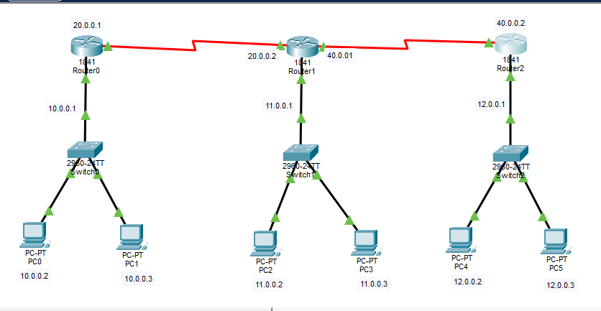

Task 2 : Assigning IPs using config tab

Network 1
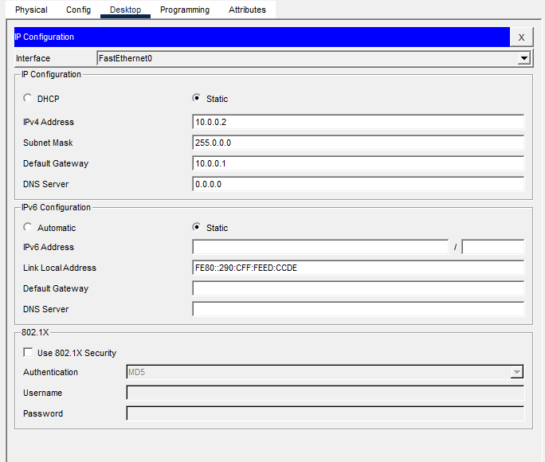

Network 2
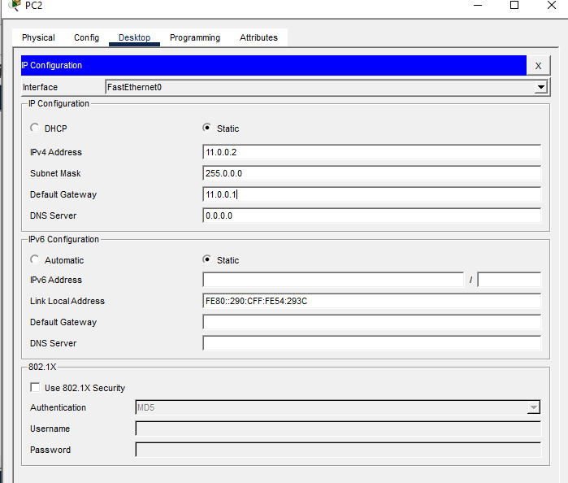

Network 3
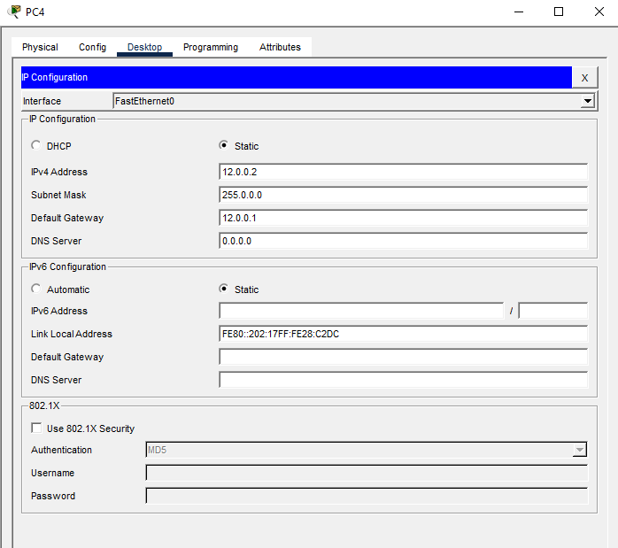

Task 3 : Config Static Routing between Router 1 and Router 2
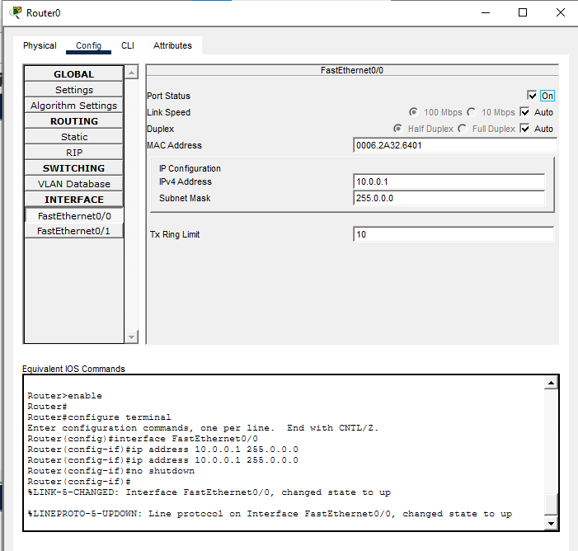
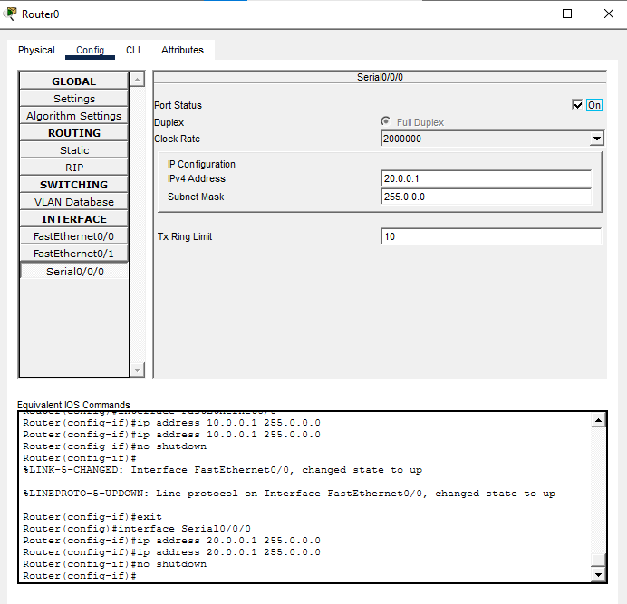
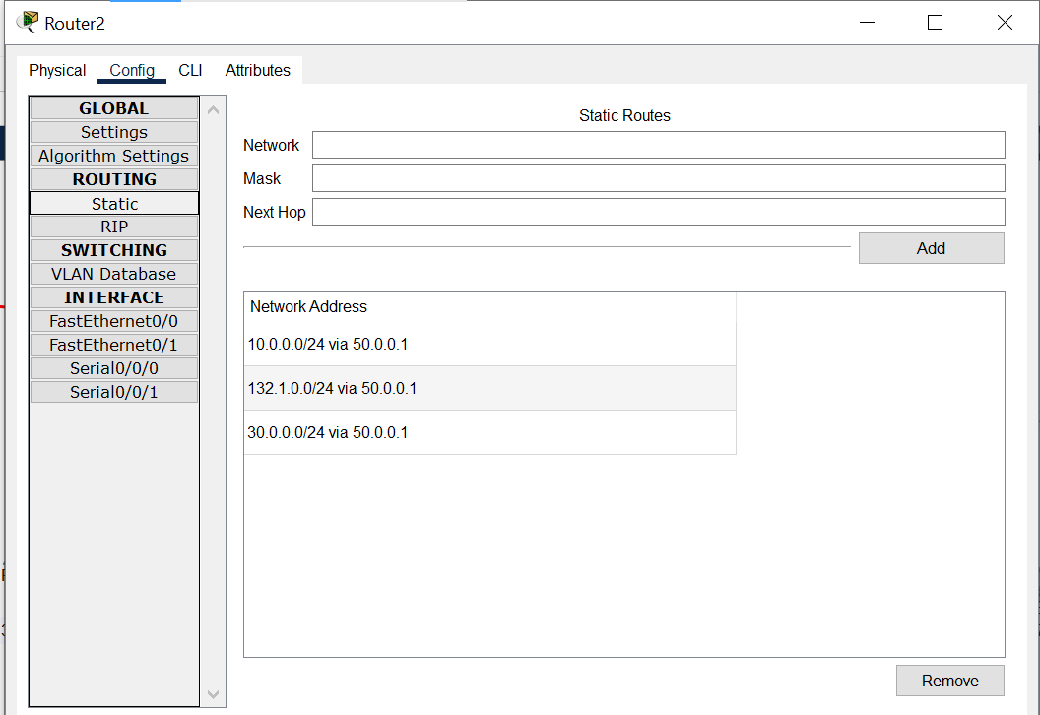
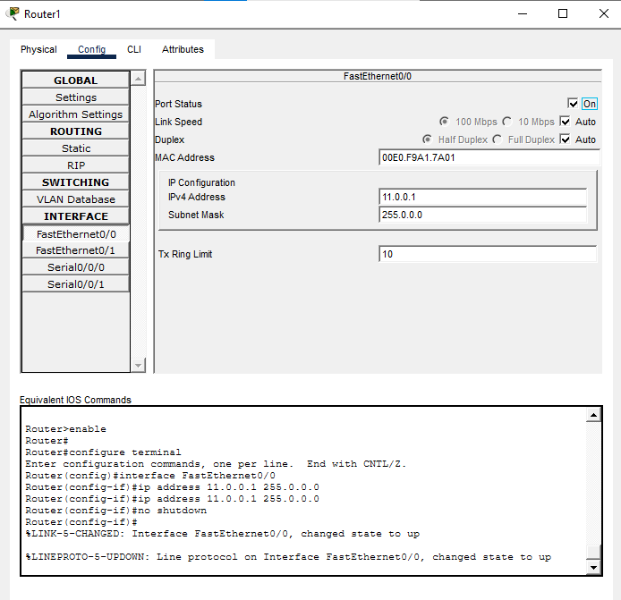
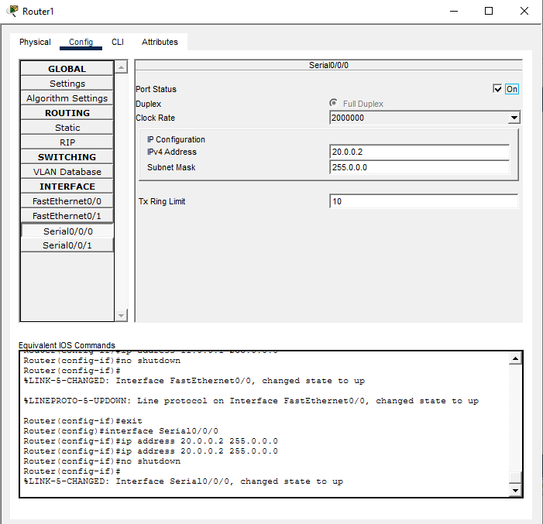
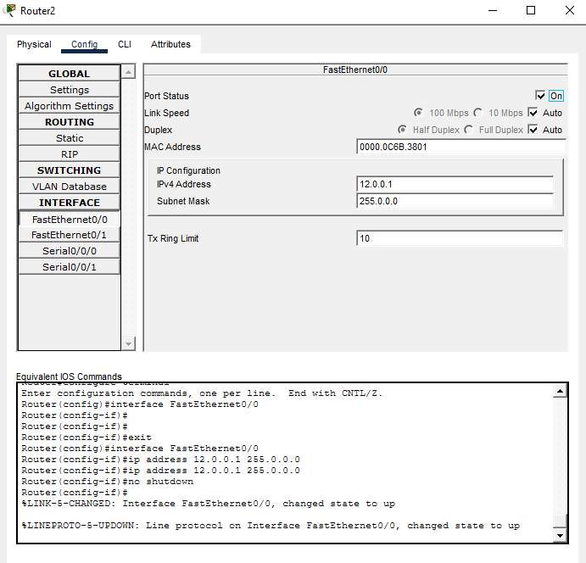
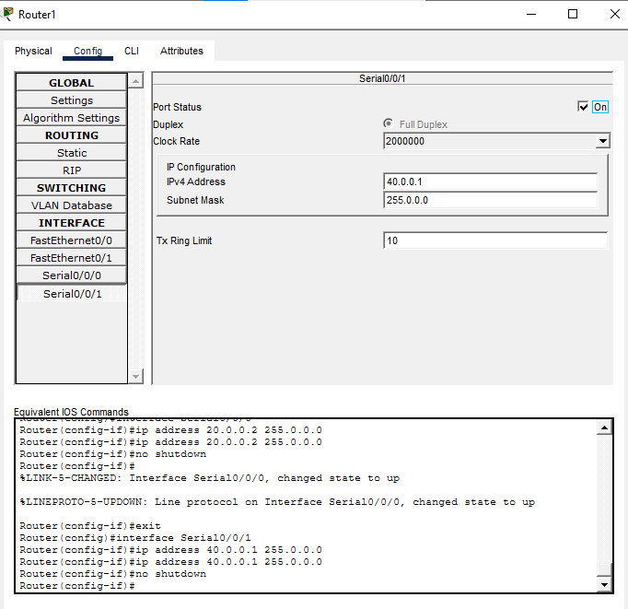
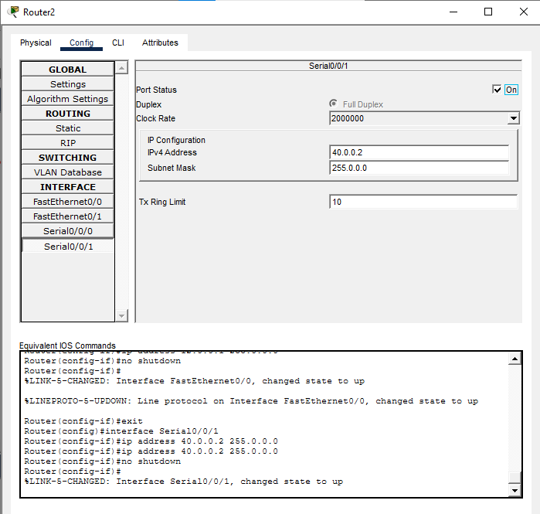

Task 4 : Pinging pc 0 to pc 3

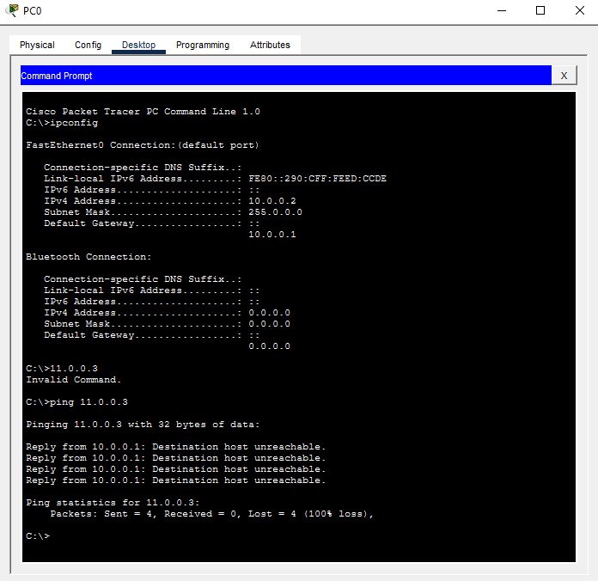
Now pc1 to pc 5
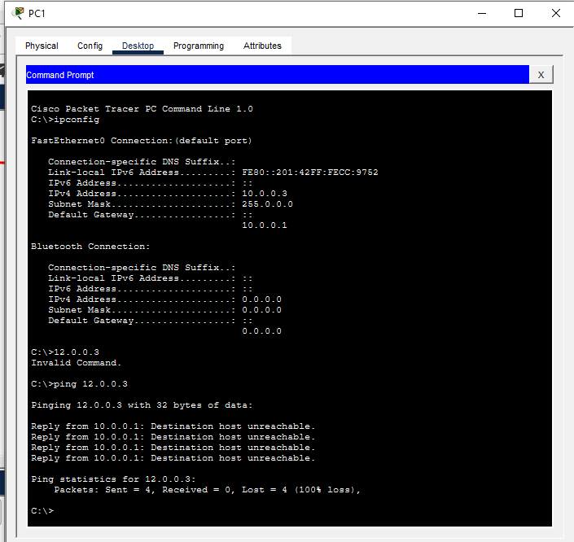

Task 5 : Extend the topology with one Router

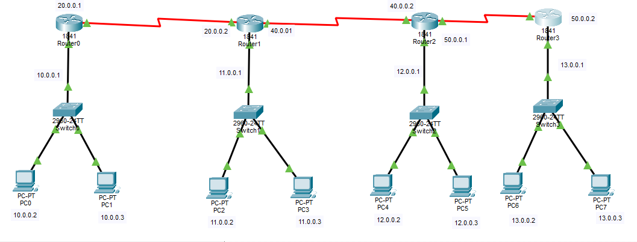
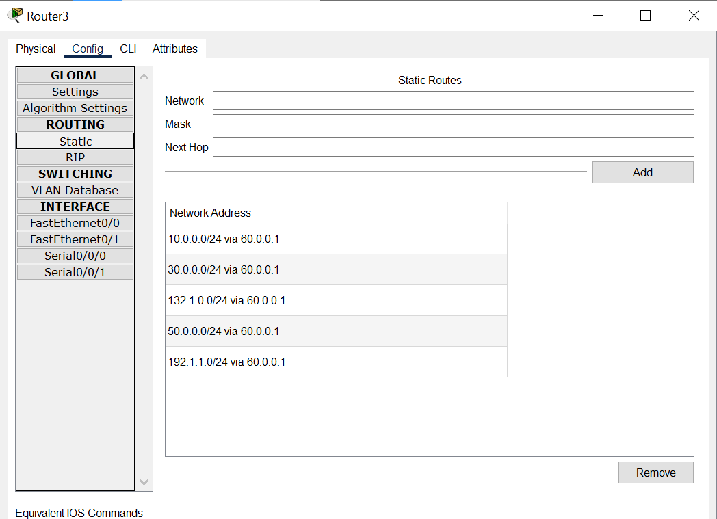

Task 6 : PC 1 TO PC 7

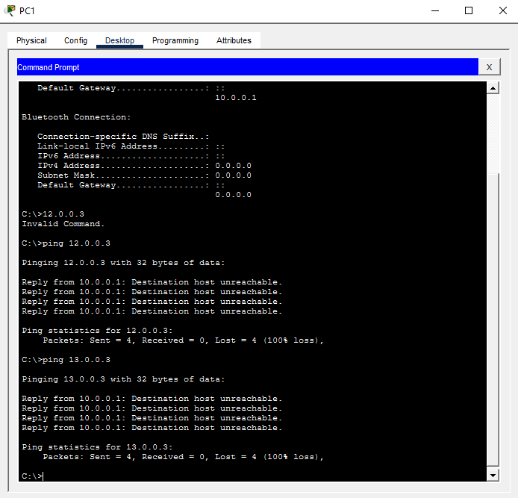

Pc 0 to Pc 5
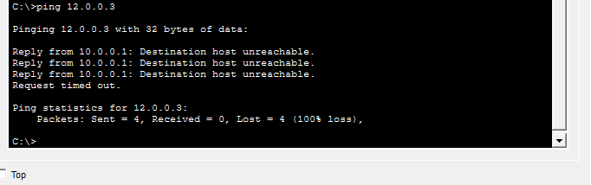
Pc 1 to Pc 3
